CLOUD COMPUTING LAB

Name: Maria Abdul Malik
Reg No: 2023-BSE-076
Submitted to: Sir Muhammad Shoaib
Class: 5B
LAB #06
Task 1 – Switch to root with su - and back to a normal user
- task1_set_root_password.png
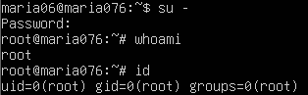
- task1_su_root.png
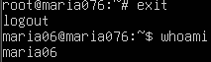
- task1_exit_to_user.png
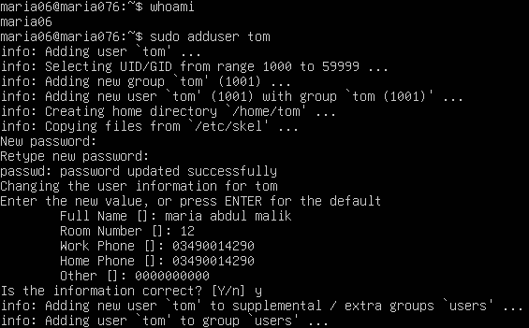

Task 2 – Create user tom and verify in passwd/group/shadow
- task2_adduser_tom.png
- task2_verify_passwd.png
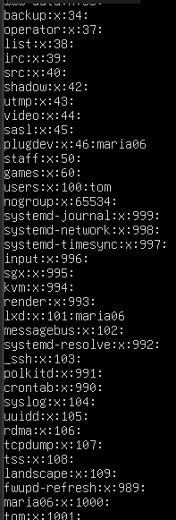
- task2_verify_group.png
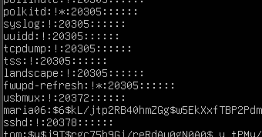
- task2_verify_shadow.png
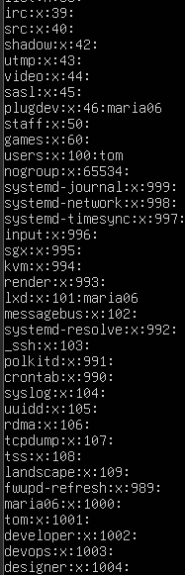
Task 3 – Create groups; change tom’s primary and secondary groups
- task3_groupadd.png
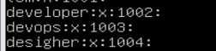
- task3_change_primary_group.png
- task3_add_secondary_groups.png
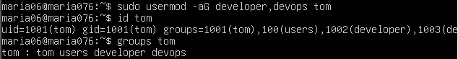
- task3_reset_secondary_groups.png
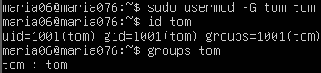
Task 4 – Create/delete users (Jerry, Scooby) and groups (jolly, anime)
- task4_add_users.p ng
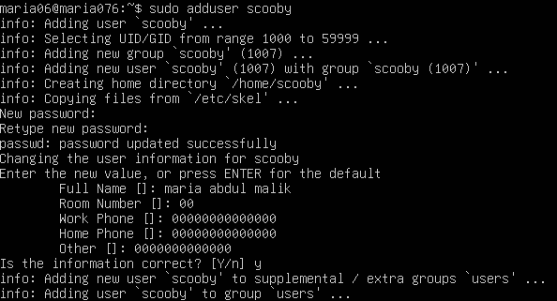
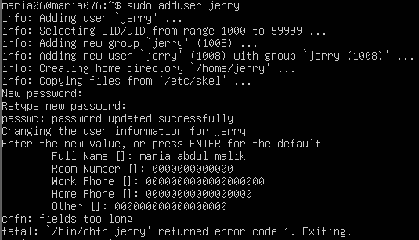
- task4_scooby_su_auth_failure.png
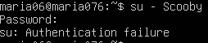
- task4_set_password_scooby.png
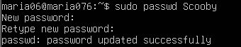
- task4_scooby_su_no_home.png
- task4_scooby_no_home.png
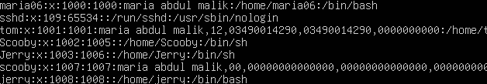
- task4_scooby_create_home.png
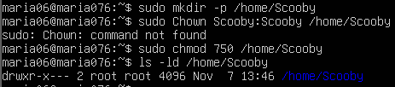
- task4_scooby_login_success.png
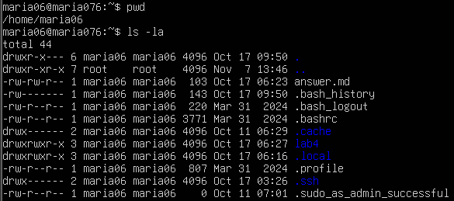
- task4_verify_users.png
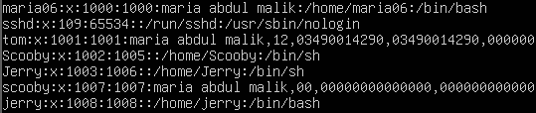
- task4_shell_switching.png
- task4_add_groups.png
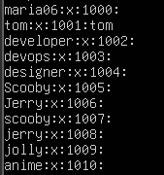
- task4_delete_groups & users.png
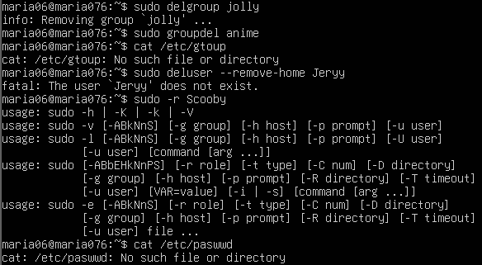
Task 5 – Create user Student; create files; set owner/group; identify file types
- task5_create_student.png
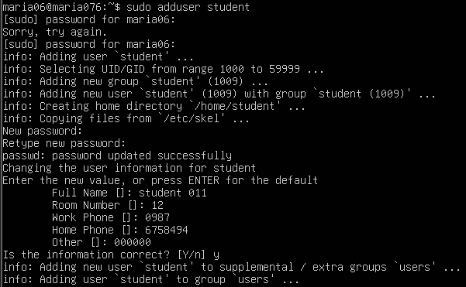
- task5_create_files.png
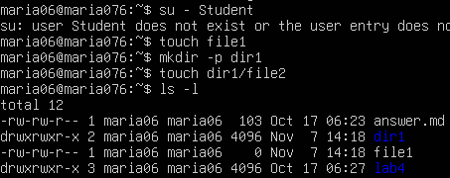
- task5_chown& chrgrp_file1.png
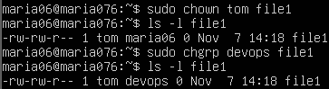
- task5_file_types.png
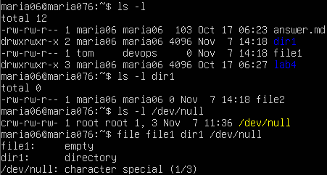
Task 6 – Change permissions using symbolic mode
- task6_su_student.png
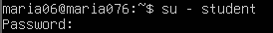
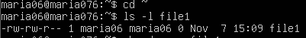
- task6_chmod_remove_rwx.png
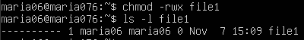
- task6_chmod_add_r.png
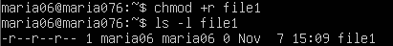
- task6_chmod_u_plus_x.png
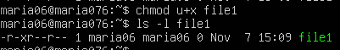
- task6_chmod_ug_plus_w.png
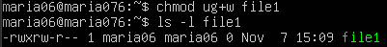
- task6_chmod_ugo_minus_rwx.png
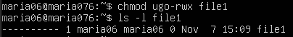

Task 7 – Change permissions using “set” symbolic form (u= g= o=)
- task7_student_context.png
- task7_chmod_set_all_rwx.png
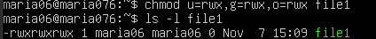
- task7_remove_exec_go.png
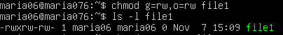
- task7_remove_all_perms.png
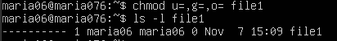

Task 8 – Change permissions using numeric (octal) mode

- task8_student_context.png

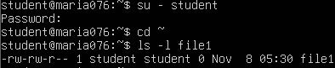
- task8_chmod_777.png
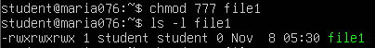
- task8_chmod_700.png
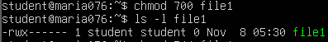
- task8_chmod_744.png
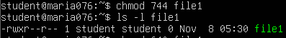
- task8_chmod_640.png
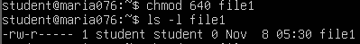
- task8_chmod_664.png
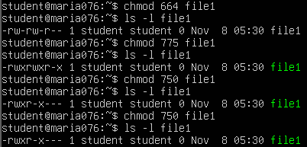
- task8_chmod_775.png
- task8_chmod_750.png
Task 9 – Practice pipes, pagers, grep, and redirects with /var/log/syslog
- task9_grep_less.png
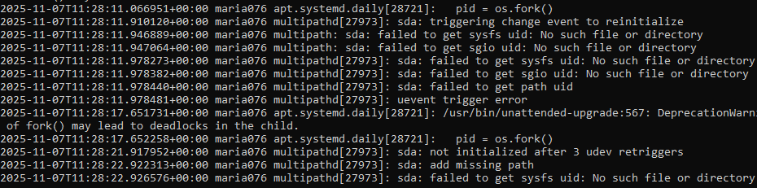
- task9_grep_more.png
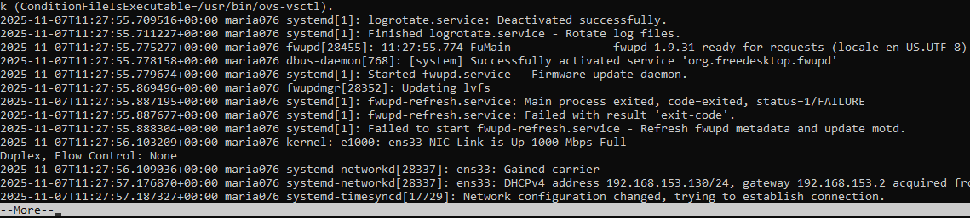
- task9_grep_head.png
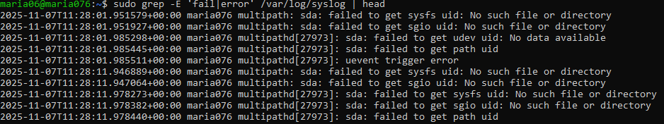
- task9_redirect_overwrite.png

- task9_redirect_append.png
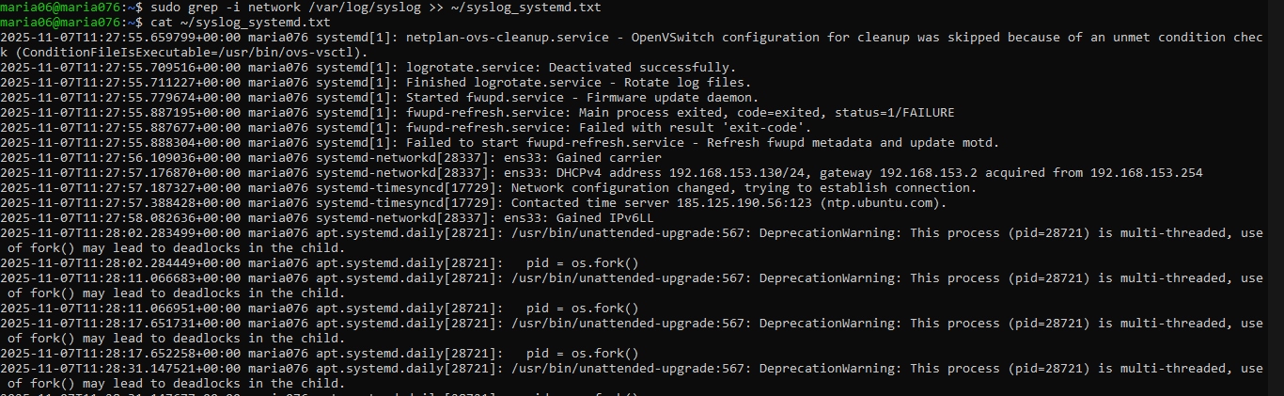
Task 10 – Script setup.sh – variables, command substitution, file/dir checks, permissions (use vim)
- task10_b1_vim.png
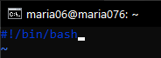
- task10_b1_run.png
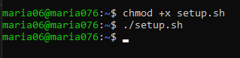
- task10_b2_vim.png
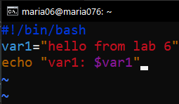
- task10_b2_run.png
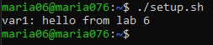
- task10_b3_vim.png
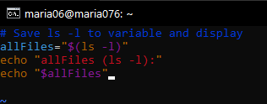
- task10_b3_run.png
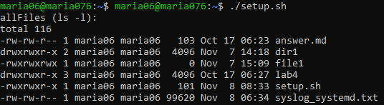
- task10_b4_vim.png
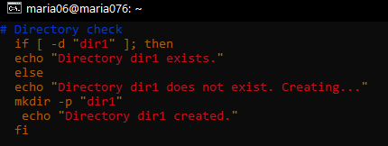
- task10_b4_run.png
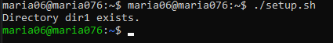
- task10_b5_vim.png
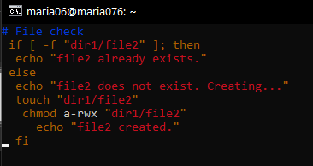
- task10_b5_run.png
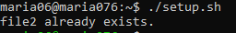
- task10_b6_vim.png
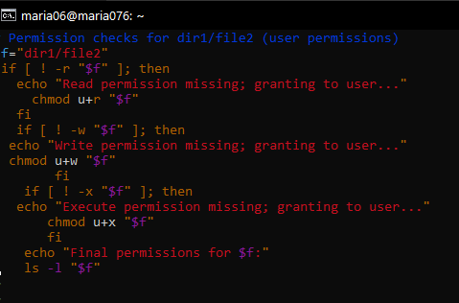
- task10_b6_run.png
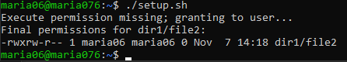
Task 11 – Script setup.sh – argument comparisons (eq, ne, gt, lt, ge, le) and string checks
- task11_b0_vim.png
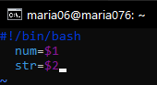
- task11_b0_run.png
- task11_b1_vim.png
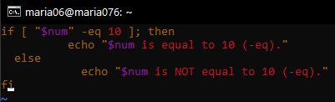
- task11_b1_run.png
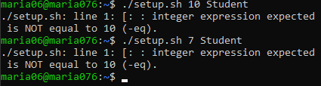
- task11_b2_vim.png
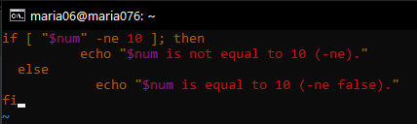
- task11_b2_run.png
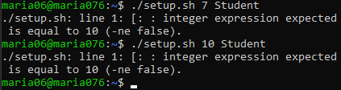
- task11_b3_vim.png
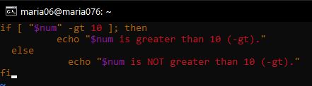
- task11_b3_run.png
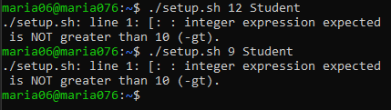
- task11_b4_vim.png
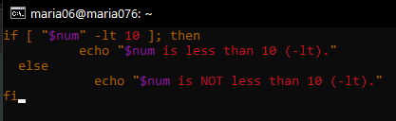
- task11_b4_run.png
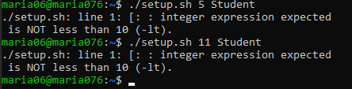
- task11_b5_vim.png
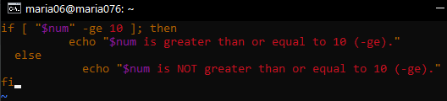

- task11_b5_run.png
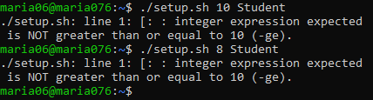
- task11_b6_vim.png
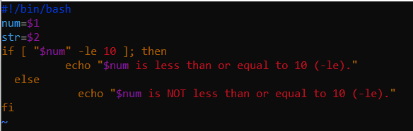
- task11_b7_vim.png
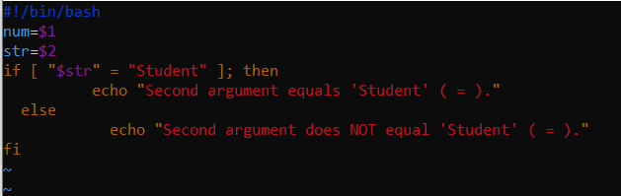
- task11_b8_vim.png
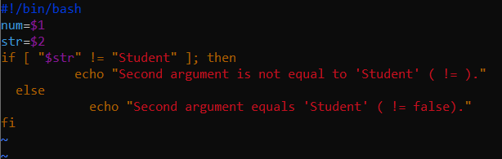
- task11_b8_run.png
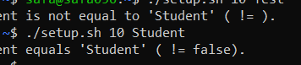
- task11_b9_vim.png
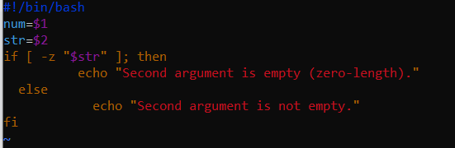
- task11_b9_run.png
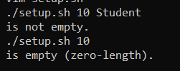

Task 12 – Script setup.sh – print all arguments with a for loop
- task12_b2_vim.png
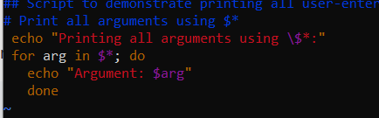
- task12_b2_run.png
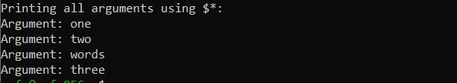

Task 13 – Script setup.sh – while loop summation and functions
- task13_b1_vim.png
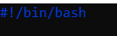
- task13_b1_run.png
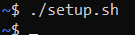
- task13_b2_vim.png
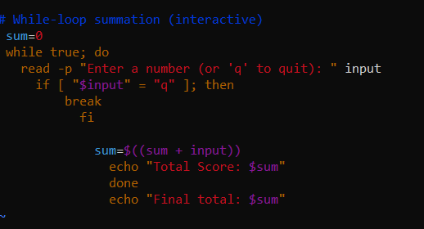
- task13_b2_run.png
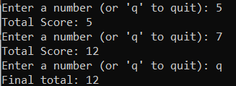
- task13_b3_vim.png
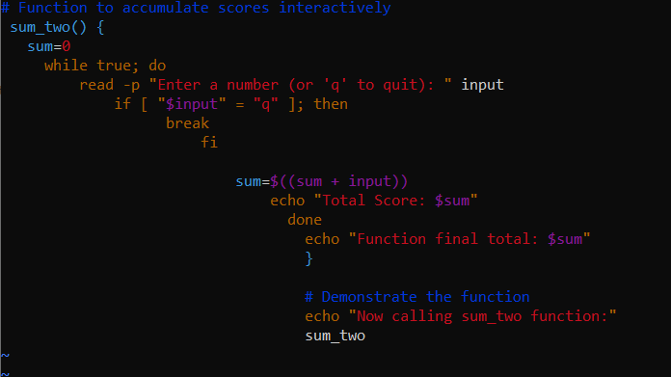
- task13_b3_run.png
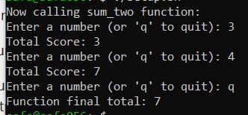
- task13_b4_vim.png
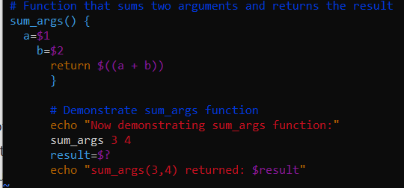
- task13_b4_run.png
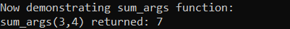
Task 14 – Codespaces GUI — fork repo, run start-desktop.sh, open VNC, stop GUI
- task14_fork.png
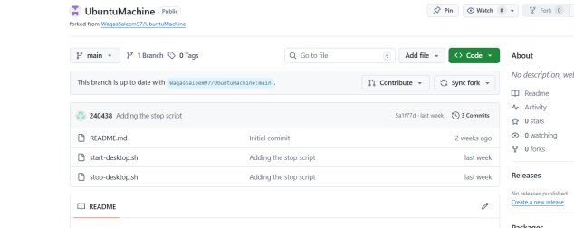
- task14_codespace_launch.png
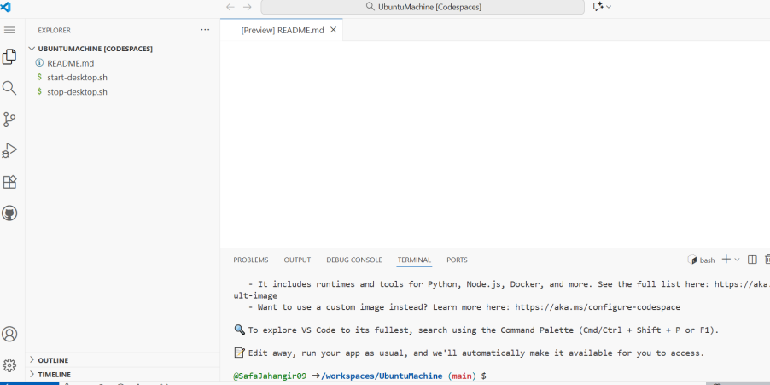
- task14_start_script_ls.png
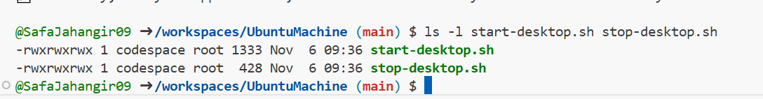
- task14_start_run.png
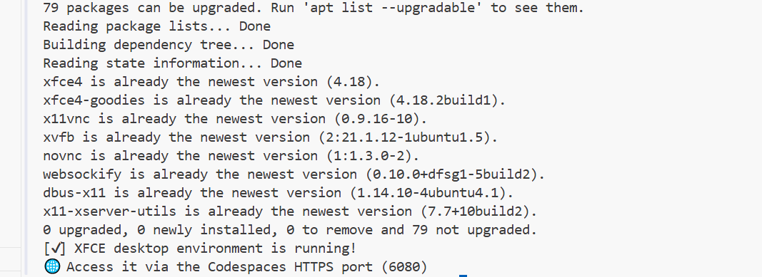
- task14_ports_view.png
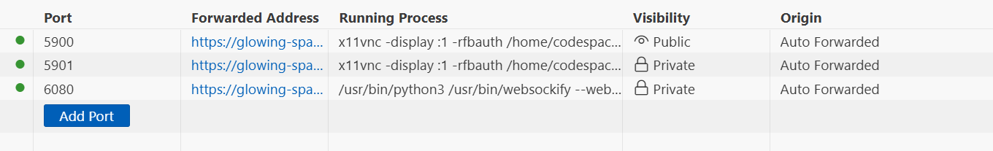
- task14_vnc_url.png
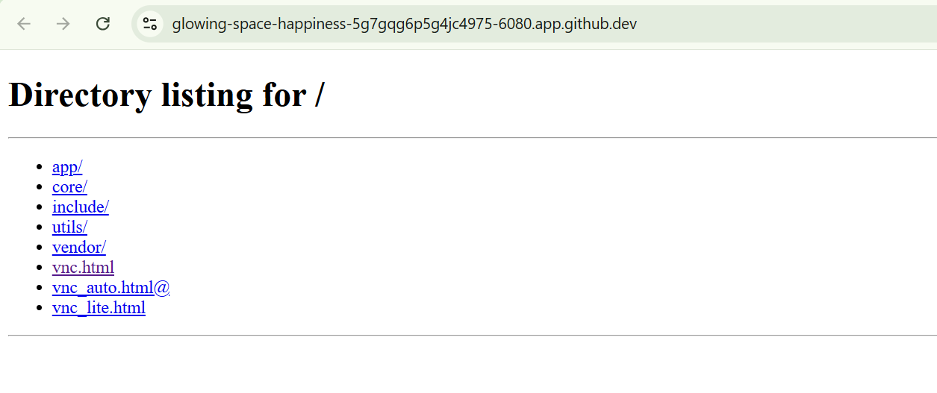
- task14_vnc_password_prompt.png
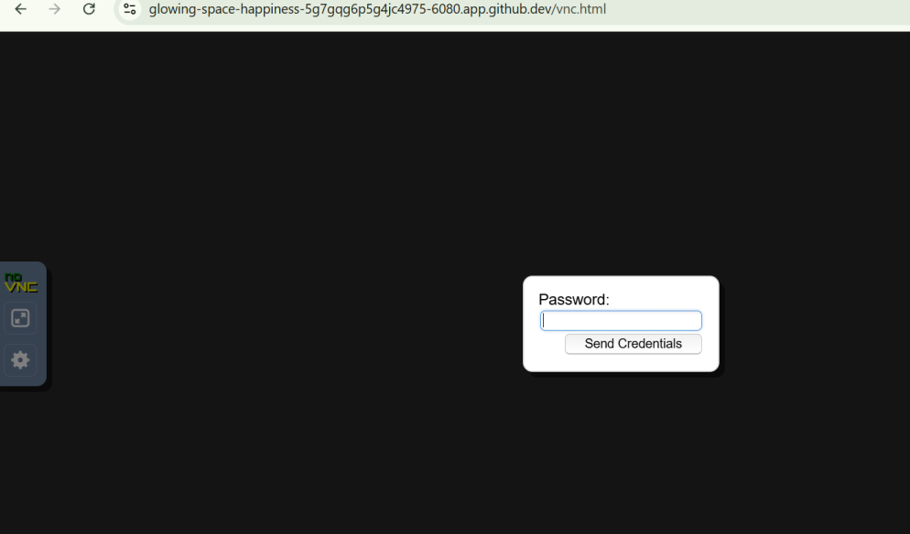
- task14_vnc_desktop.png
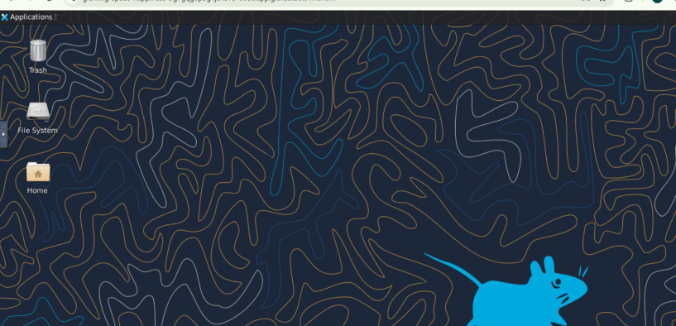
- task14_vnc_connect.png
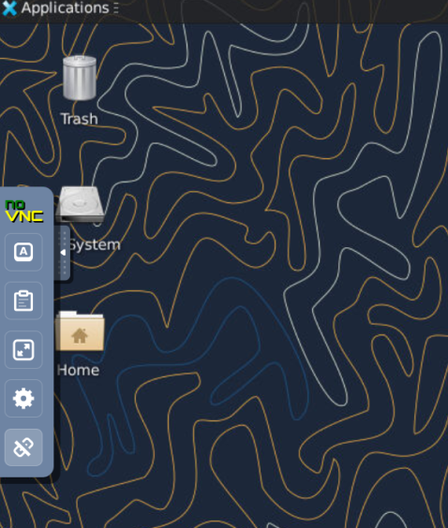
- task14_stop_run.png
